Food Delivery

System

PROJECT

DOCUMENTATION

Dt:-

Name:- Rahul Kumar

Guided By:-

Serial Number | Table of Contents | Page Number
1. | Introduction | 3
2. | Tools Description | 3
3. | Project Structure | 4
4. | Modules | 9
5. | Features | 10
6. | API Endpoints | 11
7. | Software Requirement Specification (SRS) | 16
8. | Data Dictionary | 20
9. | Data Flow Diagram (DFD) | 21
10. | ER Diagram | 22
11. | Class Diagram | 23
12. | Use Case Diagram | 25
13. | Sequence Diagram | 26
14. | Conclusion | 27
15. | Coding | 30
16. | Reference | 57
17. | Challenges | 58
18. | Limitations | 59
19. | Future Scope | 60
20. | Output Screenshots | 62 - 68

Introduction:-

Khana Khazana is a modern, user-friendly food delivery application built using the MERN Stack, which includes MongoDB, Express.js, React.js, and Node.js. This project aims to simplify the process of ordering food online by creating a digital platform where users can browse a wide variety of food items, place orders, make secure payments, and track their deliveries in real time.
The application is designed to meet the needs of three types of users: customers, administrators (admin), and delivery personnel. Customers can sign up, log in, explore the menu, add food items to their cart, and complete their orders using an integrated payment gateway (Razorpay). They can also track their order status from preparation to delivery.
Administrators have access to an admin dashboard where they can manage the food inventory, view and update orders, and monitor customer activity. This helps in keeping the system organized and ensures smooth operation of the platform.
Delivery personnel can use the platform to view assigned orders and update the delivery status, helping maintain real-time communication between the restaurant and the customer.
The use of the MERN stack allows for a powerful and scalable architecture. React ensures a smooth and interactive user experience on the frontend, while Node.js and Express.js manage the server-side logic. MongoDB, a NoSQL database, stores all the essential data including user information, food items, and order history.
Khana Khazana also focuses on security and performance. It uses JWT (JSON Web Tokens) for secure user authentication and follows best practices to protect user data during payment and data exchange.
Overall, this project offers a complete solution for online food delivery, combining efficiency, ease of use, and modern web technologies to enhance the dining experience for users while simplifying operations for administrators and delivery partners.

Tools Description:-

The development of the Khana Khazana food delivery application involved the use of several tools and technologies. Each tool played a specific role in building, managing, and testing the application:

1. MongoDB
MongoDB is a NoSQL database used to store all kinds of data in this project, such as user profiles, food items, orders, and payment details. It stores data in flexible JSON-like documents, making it easy to handle large and changing datasets.
2. Express.js
Express is a lightweight web framework used with Node.js. It helps in building the server-side logic and APIs, allowing the application to send and receive data from the database efficiently.
3. React.js
React is a JavaScript library used for creating the frontend (user interface) of the application. It helps in building fast, interactive, and responsive web pages for customers, admins, and delivery personnel.
4. Node.js
Node.js is a backend runtime environment that executes JavaScript code on the server. It connects the frontend and the database, processes API requests, handles routing, and manages backend logic.
5. Razorpay
Razorpay is an online payment gateway integrated into the app to securely handle user payments. It allows users to pay for their orders using credit/debit cards, UPI, wallets, etc.
6. Postman
Postman is a tool used to test and debug APIs. It helps developers check if the backend routes are working correctly by sending fake requests and reviewing the responses.
7. Visual Studio Code (VS Code)
VS Code is the code editor used to write, test, and debug the entire project. It supports many helpful extensions for React, Node, Git, and more.
8. Git & GitHub
Git is a version control tool used to track changes in the code. GitHub is used to store and share the code online, making it easier for collaboration and backup.

3. Project Structure:-
The project is structured as follows:
COLLEGE LIVE PROJECT/
Folder Structure for admin
├── Admin/
│ ├── assets/
│ ├── assets.js
│ ├── components/
│ │ ├── Navbar/
│ │ │ ├── Navbar.jsx
│ │ │ ├── Navbar.css
│ │ ├── Sidebar/
│ │ │ ├── Sidebar.jsx
│ │ │ ├── Sidebar.css
│ ├── pages/
│ │ │ ├── Add/
│ │ │ │ ├── Add.jsx
│ │ │ │ ├── Add.css
│ │ │ ├── List/
│ │ │ │ ├── List.jsx
│ │ │ │ ├── List.css
│ │ ├── Orders/
│ │ │ ├── Order.jsx
│ │ │ ├── Order.css
│ ├── App.js
│ ├── App.css
│ ├── index.html
Folder Structure for backend
├── Backend/
│ ├── config/
│ │ ├── db.js # Database configuration
│ ├── controllers/
│ │ ├── cartController.js # Logic for control cart
│ │ ├── foodController.js # Logic for control food
│ │ ├── orderController.js # Logic for placing orders
│ │ ├── userController.js # Logic for managing user accounts
│ ├── models/
│ │ ├── foodModel.js # Database model for food
│ │ ├── orderModel.js # Database model for orders restaurants
│ │ ├── userModel.js # Database model for user
│ ├── routes/
│ │ ├── cartRoute.js # API endpoints for cart
│ │ ├── foodRoute.js # API endpoints for food
│ │ ├── orderRoute.js # API endpoints for orders
│ │ ├── userRoute.js # API endpoints for user
│ ├── server.js # server connection
Folder Structure for frontend containing client-side logic
├── Frontend/
│ ├── public/
│ │ ├── favicon.icon
│ ├── src/
│ │ ├── components/
│ │ │ ├── AppDownload/
│ │ │ │ ├── AppDownload.jsx
│ │ │ │ ├── AppDownload.css
│ │ │ ├── ExploreMenu/
│ │ │ │ ├── ExploreMenu.jsx
│ │ │ │ ├── ExploreMenu.css
│ │ │ ├── FoodDisplay/
│ │ │ │ ├── FoodDisplay.jsx
│ │ │ │ ├── FoodDisplay.css
│ │ │ ├── FoodItem/
│ │ │ │ ├── FoodItem.jsx
│ │ │ │ ├── FoodItem.css
│ │ │ ├── Footer/
│ │ │ │ ├── Footer.jsx
│ │ │ │ ├── Footer.css
│ │ │ ├── Header/
│ │ │ │ ├── Header.jsx
│ │ │ │ ├── Header.css
│ │ │ ├── LoginPopup/
│ │ │ │ ├── LoginPopup.jsx
│ │ │ │ ├── LoginPopup.css
│ │ │ ├── Navbar/
│ │ │ │ ├── Navbar.jsx
│ │ │ │ ├── Navbar.css
│ │ │ ├── Context/
│ │ │ │ ├── StoreContext.js
│ │ ├── pages/
│ │ │ ├── Cart/
│ │ │ │ ├── Cart.jsx
│ │ │ │ ├── Cart.css
│ │ │ ├── Home/
│ │ │ │ ├── Home.jsx
│ │ │ │ ├── Home.css
│ │ │ ├── MyOrder/
│ │ │ │ ├── MyOrder.jsx
│ │ │ │ ├── MyOrder.css
│ │ │ ├── PlaceOrder/
│ │ │ │ ├── PlaceOrder.jsx
│ │ │ │ ├──PlaceOrder.css
│ │ │ ├── Verify/
│ │ │ │ ├── Verify.jsx
│ │ │ │ ├── Verify.css
│ │ ├── App.js

Admin Folder Structure
- assets/: Static assets such as images, fonts, and stylesheets.
- components/: Reusable UI components such as Navbar and Sidebar.
- pages/: Top-level pages such as Add, List, and Orders.
- App.js: Main application file.
- index.html: Entry point for the application.
Backend Folder Structure
- config/: Contains configuration files like database connection settings.
- controllers/: business logic for handling API requests.
- models/: Contains database schema definitions using an ORM like Mongoose.
- routes/: Defines API routes and maps them to controllers.
- node_modules/: Stores installed Node.js dependencies.
- app.js: Main server file where the Express application is initialized.
- .env: Stores environment variables such as API keys, database URIs, etc.
- package.json: Contains project metadata and dependencies.
Frontend Folder Structure
- src/: Main source folder for the frontend.
  - Pages/: Contains individual pages of the application, organized by functionality.
  - assets/: Stores all static assets, such as images and fonts.
  - styles/: Contains global CSS and reusable styles for the application.
  - index.js: The entry point that renders the React application.
  - App.js: The main component that wraps the entire application.
Root Files
- .gitignore: Specifies files and folders to ignore in Git.
- package.json: Holds project metadata and dependencies.
- README.md: Provides project documentation and setup instructions.

Tests and Monitoring
- App.test.js: Contains test cases for the main App component.
- setupTests.js: Configures testing libraries.
- reportWebVitals.js: Measures app performance

4. MODULES:-

The Khana Khazana application is divided into several functional modules. Each module handles a specific part of the application’s workflow and responsibilities.

🔹 1. User Module (Customer)
- Allows new users to register and login
- Enables users to browse food by category
- Lets users place, track, and cancel orders
- Allows users to view order history and edit their profile

🔹 2. Admin Module
- Admin can login with secure credentials
- Add, update, and delete food items
- View all user orders
- Update order status (e.g., Preparing, Out for Delivery, Delivered)

🔹 3. Delivery Module
- Assigned delivery personnel can log in
- View assigned orders
- Update delivery status (e.g., Picked up, Delivered)

🔹 4. Cart & Checkout Module
- Users can add multiple items to a cart
- Update quantity or remove items
- Calculate order total with taxes
- Proceed to checkout and confirm payment

🔹 5. Payment Module
- Integrated with Razorpay for online payments
- Ensures secure transactions
- Stores payment status with order info

🔹 6. Authentication Module
- Uses JWT (JSON Web Tokens) for session management
- Protects admin and user-specific routes
- Ensures only authorized users access their features

🔹 7. API & Backend Logic Module
- Handles requests and responses between frontend and backend
- CRUD operations for food, user, order, cart
- Validates data and handles server-side errors

5. Features:-

For Admin
- Add New Food: Admin can add new food into the list and delete from the list.
- Check List: Admin can check all food lists.
- Check All Orders: Admin can check all food orders.
- Order Status: Admin can edit order status.
For Customer
- Sign Up and Login: customers can register and login into the app.
- View food: customer can view all food category wise
- Order food: customer can order any food he wants.
- Check Status: customer can check their order status.

6. API Endpoints:-

Cart Route
- GET /cart: Retrieve cart contents
- POST /cart: Add item to cart
- DELETE /cart: Clear cart
Food Route
- GET /foods: Retrieve list of available foods
- GET /foods/:id: Retrieve food details by ID
- POST /foods: Create new food item
- PUT /foods/:id: Update food item details
- DELETE /foods/:id: Delete food item
Order Route
- GET /orders: Retrieve list of orders
- POST /orders: Create new order
- PUT /orders/:id: Update order status
- DELETE /orders/:id: Cancel order
User Route
- GET /users: Retrieve list of users
- GET /users/:id: Retrieve user details by ID
- POST /users: Create new user
- PUT /users/:id: Update user details
- DELETE /users/:id: Delete user
Authentication Route
- POST /login: Login user
- POST /register: Register new user
- POST /logout: Logout user

7. Software Requirement Specification (SRS):-

1. Introduction

1.1 Project Title

Khana Khazana – Online Food Delivery System

1.2 Purpose

The purpose of this project is to design and develop a web-based food delivery platform that allows users to browse a menu, place food orders, make payments online, and track delivery status. The application aims to simplify food ordering for customers and streamline order management for administrators and delivery personnel.

1.3 Scope

Khana Khazana is an online food ordering system developed using the MERN Stack (MongoDB, Express.js, React.js, Node.js). The system includes secure login and authentication, a categorized food menu, a cart and checkout process, Razorpay integration for payments, and real-time order status updates.

2. Overall Description

2.1 User Types and Characteristics

Customer: Can sign up, log in, view menu, place orders, and track order status.

Admin: Can manage food items, view and manage orders, and change order statuses.

Delivery Staff: Can view assigned orders and update delivery status.

2.2 Assumptions and Dependencies

Internet connection is required to access the system.

MongoDB database must be running locally or hosted (MongoDB Atlas).

Razorpay account is required for payment integration.

JWT tokens are used for session management.

3. Functional Requirements

3.1 Customer Functions

Register and log in with email and password

View food items by category

Add or remove items from cart

Place an order with payment

View current and past orders

Track order status

3.2 Admin Functions

Login with secure credentials

Add, update, or delete food items

View all placed orders

Update order statuses (e.g., Food Processing, Out for Delivery, Delivered)

3.3 Delivery Staff Functions

View assigned deliveries

Update order status upon delivery

4. Non-Functional Requirements

4.1 Performance

Fast page load and data retrieval using optimized backend APIs.

Able to handle up to 1000+ concurrent users (scalable).

4.2 Security

Passwords are hashed using bcrypt.

JWT-based authentication is used for all protected routes.

Payment is processed securely via Razorpay.

4.3 Usability

Clean, intuitive user interface using React.js

Mobile responsive design

4.4 Maintainability

Code is modular and well-commented

Easy to update components independently

5. System Requirements

5.1 Software Requirements

Node.js v14 or above

MongoDB (local or Atlas)

Visual Studio Code or any IDE

Web browser (Chrome, Firefox, Edge)

Postman (for API testing)

5.2 Hardware Requirements

Minimum 4 GB RAM

1.5 GHz dual-core processor or higher

Stable internet connection

8.Data Dictionary:-

Entity | Field Name | Data Type | Description
User | userId | ObjectId | Unique ID of the user
 | name | String | Full name of the user
 | email | String | Email address
 | password | String | Encrypted password
 | role | String | Role (admin, customer, delivery)
Food | foodId | ObjectId | Unique ID of the food item
 | name | String | Name of the food
 | description | String | Food description
 | price | Number | Price of the food
 | category | String | Food category
Order | orderId | ObjectId | Unique ID of the order
 | userId | ObjectId | ID of the customer who placed order
 | items | Array | List of food items in the order
 | amount | Number | Total amount of the order
 | status | String | Status of the order
Cart | cartId | ObjectId | Unique ID of the cart
 | userId | ObjectId | Owner of the cart
 | items | Array | List of food items in the cart

9.Data Flow Diagram (DFD):-

A Data Flow Diagram (DFD) visually represents how data flows within the system and how the system interacts with external entities. The DFD for Khana Khazana is designed across four levels for clarity and detailed understanding

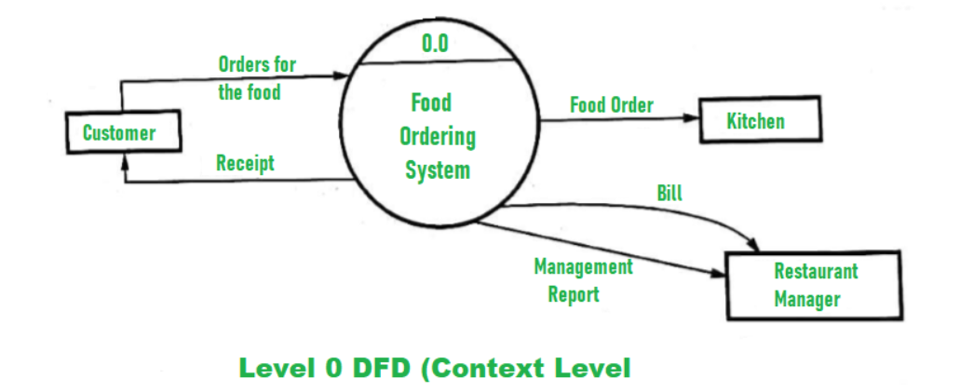

🔹 Level 0 DFD – Context Diagram
This is the highest level of abstraction showing the overall system as a single process and its interaction with external entities.
External Entities:
- Customer
- Admin
- Delivery Person
Main Process:
- Food Ordering System
Data Flows:
- Customer places a food order → System
- System generates bill/receipt → Customer
- Admin manages food items and orders
- Delivery person updates order delivery status
Outputs:
- Order confirmation
- Bill/receipt
- Order status updates
- Management report

🔹 Level 1 DFD – Functional Processes

Flows:
- Customer sends order data → Process Order
- Admin updates food menu → Manage Food Menu
- System sends status updates → Customer and Delivery
- Payment processed through Razorpay → Handle Payment
- Reports generated from sales and inventory → Admin

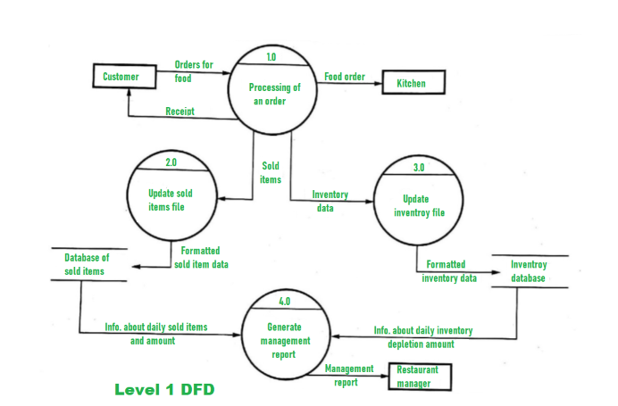

🔹 Level 2 DFD – Detailed View of “Process Order”

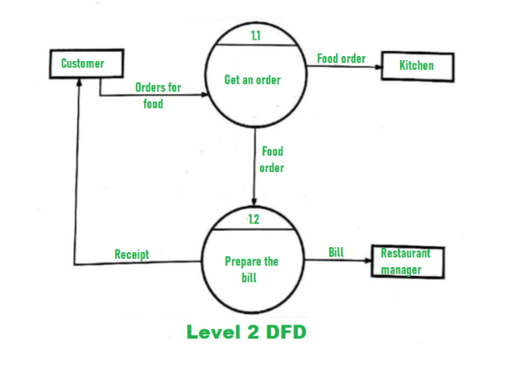

🔹 Level 3 DFD – Generate Management Report (Admin)

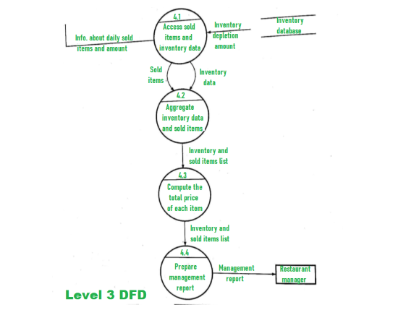

10.Entity-Relationship (ER) Diagram:-

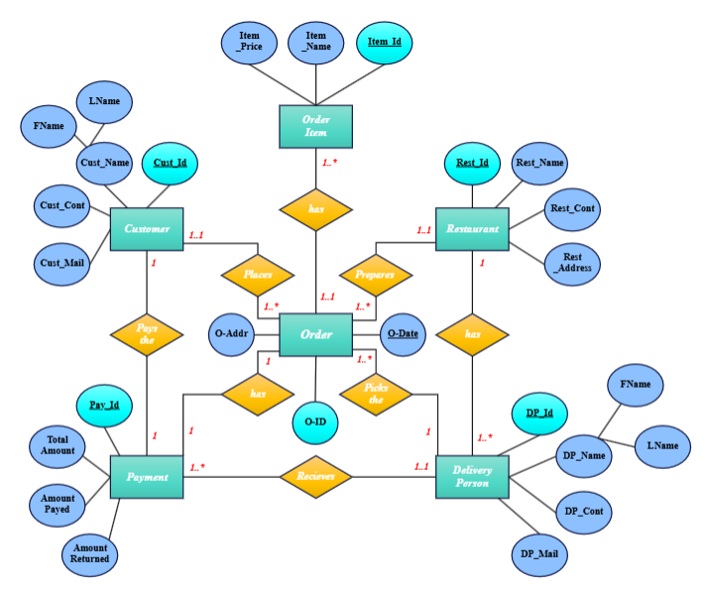

11.Class Diagram:-

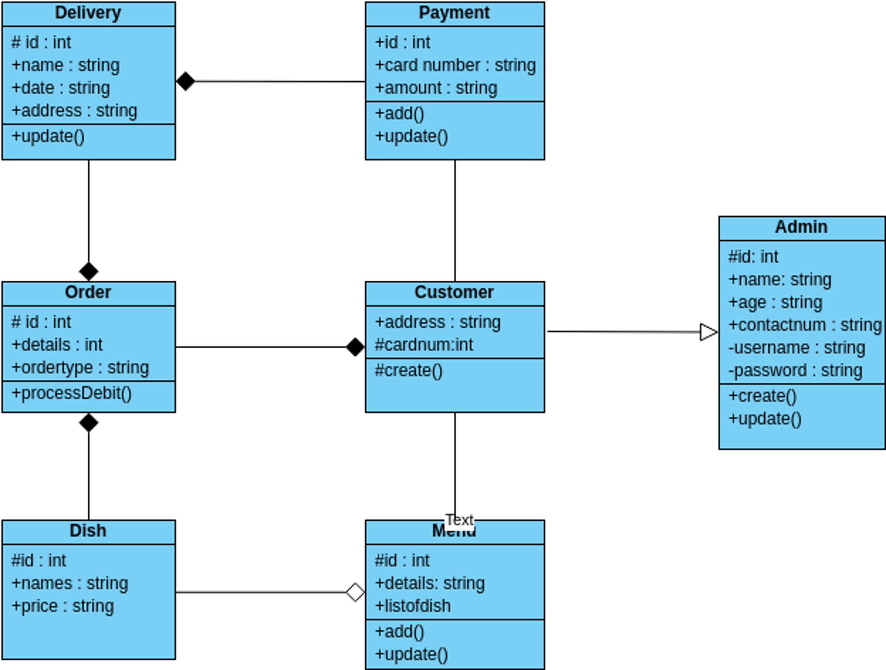

12. Use Case Diagram:-

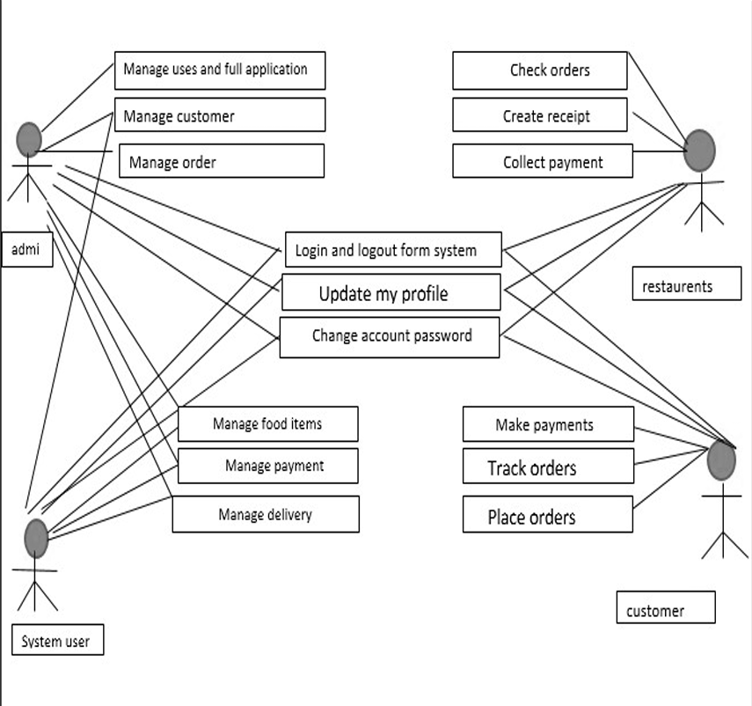

13. Sequence Diagram:-

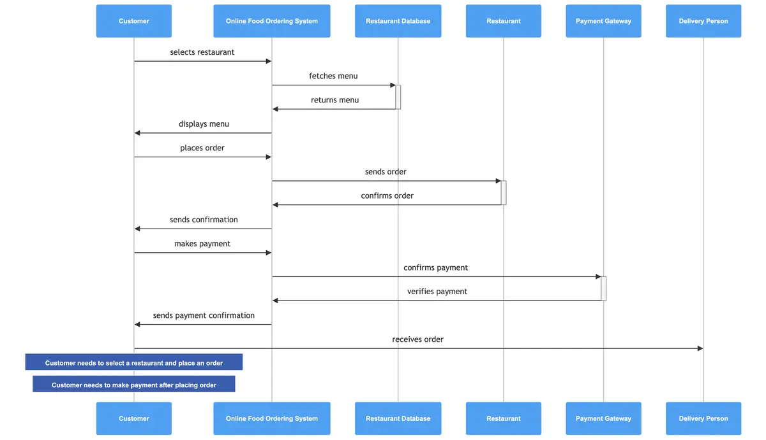

14.Conclusion:-

It provides a simple way for customers to order food from a restaurant using their device, allowing them to enjoy their food within 45 minutes. It stores customer and food item details and generates bills to reduce time wasting and avoid misunderstandings compared to traditional in-person ordering. The system also allows users to easily modify their profile information like delivery addresses. Overall, the project aims to provide easy data flow, customer satisfaction, and less work through the developed online platform.

FRONTEND
Frontend-Live-Project/
Node Modules
  - node_modules/: Folder containing installed npm packages
Public: public/: Folder containing static assets accessible from the web
  - index.html: Main HTML file for the application
  - favicon.ico: Favicon for the application
  - manifest.json: Web app manifest file
Source (Src): Folder containing application source code
  - components/: Reusable UI components
  - containers/: Components that wrap other components
  - images/: Image assets
  - styles/: CSS stylesheets
  - App.js: Main application component
  - index.js: Entry point for the application
Index
  - index.html: Entry point for the application (served from public/ folder)
  - index.js: Entry point for the application (served from src/ folder)
Package JSON: File containing project metadata and dependencies
Readme: File containing project information and setup instructions

NODE MODULES
To install the node_modules folder in your frontend project, you need to install the project's dependencies listed in the package.json file using the following command:
Command to Install Node Modules:-
npm install.

1. Basic Information
- name: The name of the project is "front". This could refer to a front-end application or simply a naming convention used for the project.
- version: The version of the project is 0.1.0, indicating this is an early version of the project.
- private: The project is marked as true for "private", meaning it cannot be accidentally published to the npm registry.

2. Dependencies
These are the libraries and packages your project relies on to function. Here are the dependencies and their purposes:
- axios: A promise-based HTTP client for making API requests.
- react: The React library itself (version 18.2.0), used for building the UI of the app.
- react-dom: This package provides the DOM-related functions for React (used with react to render components).
- react-router-dom: A library for routing in React applications, allowing for page navigation without a page reload.
- react-toastify: A library for adding toast notifications to your React app.
- web-vitals: A package for measuring and reporting on the core web vitals (performance metrics) of a website.

3. Scripts
These are custom commands you can run using npm. These are commonly used tasks during development:
- start: Runs react-scripts start, which starts the development server, typically at http://localhost:3000, with hot reloading enabled.
- build: Builds the project for production. The set "GENERATE_SOURCEMAP=false" part ensures that the source maps are not generated (which can help reduce build size).
- test: Runs tests using react-scripts test. This runs the testing framework (Jest) and looks for test files in the project.
- eject: Ejects the configuration from create-react-app. This gives you full control over the configuration files (webpack, Babel, ESLint, etc.), but it is not reversible.

4. ESLint Configuration
- eslintConfig: Specifies the ESLint configuration for the project:
  - extends: This section includes base configurations for ESLint. It extends react-app for general React rules and react-app/jest for Jest testing rules.
  - ESLint is a tool for identifying and fixing JavaScript code quality and style issues.

5. Browserslist
- browserslist: Specifies the list of supported browsers for both production and development environments.
  - production: This configuration tells tools (e.g., Babel, Autoprefixer) to support browsers with more than 0.2% market share, excluding "dead" browsers and "Opera Mini."
  - development: In the development environment, it supports the last version of Chrome, Firefox, and Safari browsers. This is useful for minimizing the browser range to improve build performance in development.

Summary:
- The project is a React application using Create React App (react-scripts).
- It includes popular libraries for testing (@testing-library/react), UI (bootstrap, react-toastify), and making HTTP requests (axios).
- The scripts section defines commands for starting, building, testing, and ejecting the app.
- The eslintConfig and browserslist help with code quality and browser compatibility respectively.

15.Coding:

Install axios:
Run the following command to install:-
npm install axios
Verify Installation:
Once installation is complete, check the node_modules folder to ensure axios is installed. You can also confirm it by looking at the package.json file under the "dependencies" section:

"dependencies": {
"axios": "^1.7.9"
}
Use axios in your project:

After installing axios, you can import and use it in your React project like this:

import axios from 'axios';
// Example usage:
axios.get('https://api.example.com/data')
.then(response => {
console.log(response.data);
})
.catch(error => {
console.error(error);
});

1. src/
The src folder contains the main source code for the React application. All the components, assets, and logic reside here.
Pages/
This folder likely holds individual React components or pages for routing purposes. For example, pages like Home.js, About.js, or Dashboard.js might reside here. It organizes the structure of the app by separating page-specific components.
App.css
This file contains the CSS styles specific to the App.js component. It helps in maintaining the styling of the main app layout.
App.js
The main React component that serves as the root of the application. It renders the primary structure of the app, usually containing the routes or other major components.
App.test.js
A testing file created by default in React apps (if testing is enabled). It typically uses the Jest testing library to validate the functionality of the App.js component.
index.css
Global CSS styles for the entire application. It is usually imported in index.js to apply the styles across the app.
index.js
The entry point of the React app. It renders the App.js component into the root DOM element (<div id="root"> in index.html). This file is critical for bootstrapping the React app.
logo.svg
A default logo file included in React apps. It's usually displayed in the initial boilerplate project and can be replaced with a custom logo.

reportWebVitals.js
A utility file for measuring and logging app performance metrics (e.g., page load time). It can be used to send performance data to analytics services.

setupTests.js
This file configures the testing environment for the app. It’s automatically included when using create-react-app with a testing setup like Jest.

2. Project Root Files
These files are located in the root of the project folder, outside of src.

.gitignore
This file specifies files and directories that should be ignored by Git. For example, node_modules, build outputs, and environment files are commonly listed here.

package-lock.json
This file locks the exact versions of all installed dependencies. It ensures consistent builds across different environments.

package.json
A crucial file in a Node.js project. It defines the project metadata, dependencies, and scripts. Key fields include:
- dependencies: Libraries required for the app to run.
- scripts: Commands to build, test, or run the app (e.g., npm start).

README.md
A markdown file that usually contains information about the project. It may include setup instructions, usage details, and other relevant documentation.

NODE MODULES

The node_modules folder in a frontend project contains all the dependencies (libraries and modules) required for the application to run, build, and function correctly. These dependencies are installed using npm (Node Package Manager) and are listed in the package.json file. Here's an explanation of common types of node_modules used in frontend projects:

The node_modules folder in a frontend project contains all the dependencies (libraries and modules) required for the application to run, build, and function correctly. These dependencies are installed using npm (Node Package Manager) and are listed in the package.json file. Here's an explanation of common types of node_modules used in frontend projects:

1. Framework/Library Modules

react: Core React library for building UI components.

react-dom: Provides DOM-specific methods that allow React components to be rendered in the browser.

react-router-dom: Used for routing in a React application.

redux/@reduxjs/toolkit: State management libraries for React applications (if used).

axios: Library for making HTTP requests from the frontend to a backend API.

firebase: Used for Firebase services, such as authentication, database, or storage.

2. Build Tools

webpack: A module bundler used to compile JavaScript, CSS, and other assets into a single file.

babel: A JavaScript compiler used to transform modern JavaScript (ES6+) into a version compatible with older browsers.

esbuild/swc: Modern alternatives to Babel and Webpack for faster builds.

3. Styling Modules

bootstrap: CSS framework for building responsive designs.

tailwindcss: Utility-first CSS framework for styling components.

sass or node-sass: Preprocessor for writing modular and nested CSS.

4. Testing Libraries

jest: A testing framework commonly used for JavaScript and React projects.

@testing-library/react: Helps test React components by simulating user interactions.

@testing-library/jest-dom: Provides custom matchers for asserting DOM nodes.

5. Utility Libraries

lodash: Utility library for manipulating objects, arrays, and strings.

moment/dayjs: Libraries for handling and formatting dates and times.

uuid: Generates unique IDs for React keys or other unique elements.

6. Development Dependencies

These modules are installed as devDependencies and are used only during development.

eslint: Linter for identifying and fixing coding issues.

prettier: Code formatter for maintaining consistent style.

react-scripts: A utility provided by Create React App to simplify configuration for building, testing, and running a React app.

webpack-dev-server: Provides a live development server for real-time code updates.

7. Build Modules

dotenv: For managing environment variables (e.g., API keys) in development and production.

workbox-webpack-plugin: Helps with building Progressive Web Apps (PWAs).

How node_modules Are Managed:

Dependencies and their versions are listed in the package.json file.

Installed by running npm install or yarn install.

Important: The node_modules folder should not be modified manually or included in version control (e.g., Git). Instead, it is regenerated using package.json and package-lock.json.

Common Issues with node_modules:

Missing or Corrupted Modules:

Fix by running:

bash

Copy code

rm -rf node_modules package-lock.json

npm install

Large Folder Size:

The node_modules folder can become very large because of nested dependencies. This is normal for frontend projects.

Compatibility Issues:

Use npm audit to check for vulnerabilities and fix outdated packages.

Frontend folder image
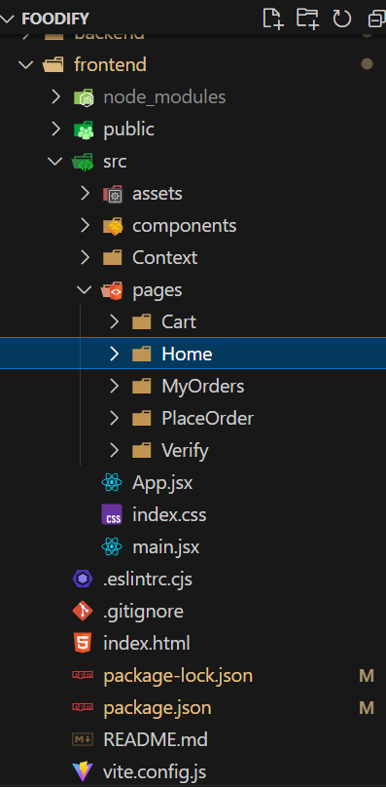

BACKEND

Project Name: BACKEND-LIVE-PROJECT

This indicates that the project is a live backend application, likely developed using Node.js with Express.js for creating APIs.

2. Folders

Backend/

This is the main folder for the backend portion of the application. It contains all the configuration files, models, routes, and other essential components required for the backend.

config/

This folder is typically used for configuration files, such as:

Database connection files (e.g., MongoDB, MySQL, etc.).

Environment-specific settings (e.g., development, production).

Example:-

const mongoose = require('mongoose');

const connectDB = async () => {

try {

await mongoose.connect(process.env.MONGO_URI, { useNewUrlParser: true, useUnifiedTopology: true });

console.log('MongoDB Connected');

} catch (error) {

console.error('Database Connection Failed', error);

process.exit(1);

}

};

module.exports = connectDB;

1. Project Name: BACKEND-LIVE-PROJECT
This indicates that the project is a live backend application, likely developed using Node.js with Express.js for creating APIs.

2. Folders

Backend/
This is the main folder for the backend portion of the application. It contains all the configuration files, models, routes, and other essential components required for the backend.

config/
This folder is typically used for configuration files, such as:
- Database connection files (e.g., MongoDB, MySQL, etc.).
- Environment-specific settings (e.g., development, production).
- Example:
const mongoose = require('mongoose');
const connectDB = async () => {
try {
await mongoose.connect(process.env.MONGO_URI, { useNewUrlParser: true, useUnifiedTopology: true });
console.log('MongoDB Connected');
} catch (error) {
console.error('Database Connection Failed', error);
process.exit(1);
}
};

module.exports = connectDB;

models/
This folder contains data models or schemas for the database. These models define the structure of the data stored in the database.
Examples of the models inside this folder:
  - foodModel.js: Defines the structure and schema for food items.
  - orderModel.js: Defines the structure and schema for customer orders.
  - userModel.js: Defines the structure and schema for user accounts, including customers, restaurants, and administrators.

node_modules/
This folder contains all the dependencies and packages installed via npm (Node Package Manager). These packages are defined in the package.json file. Examples:
- Express.js for handling HTTP requests.
- Mongoose for MongoDB integration.
- dotenv for managing environment variables.

routes/
This folder contains the API routes of the application. Each file corresponds to a specific feature/module and contains endpoints for CRUD operations.

cartRoute.js: Handles cart-related operations, such as adding, removing, and updating items.

foodRoute.js: Handles food-related operations, such as retrieving food items, creating new items, and updating existing ones.

orderRoute.js: Handles order-related operations, such as creating new orders, retrieving order history, and updating order status.

userRoute.js: Handles user-related operations, such as user registration, login, and account management.

Example of a route (using Express):
import express from 'express';
import { addFood, listFood, removeFood } from '../controllers/foodController.js';
import multer from 'multer';
const foodRouter = express.Router();

//Image Storage Engine (Saving Image to uploads folder & rename it)

const storage = multer.diskStorage({
destination: 'uploads',
filename: (req, file, cb) => {
return cb(null,`${Date.now()}${file.originalname}`);
}
})

const upload = multer({ storage: storage})

foodRouter.get("/list",listFood);
foodRouter.post("/add",upload.single('image'),addFood);
foodRouter.post("/remove",removeFood);

export default foodRouter;

3. Files

.env
This file stores environment variables that are used throughout the project. These variables are kept secret (e.g., database credentials, API keys).

Example:
PORT=4000
MONGO_URI=mongodb://localhost:2174/MyDatabase
JWT_SECRET=mysecretkey

.gitignore
Specifies files and folders to be ignored by Git. Commonly ignored items include:
- node_modules/
- .env
- logs/
- Example content:
node_modules/
.env
logs/
app.js
The main entry point for the backend application. It initializes the server, middleware, and routes.
Example content:
// app config
const app = express()
const port = process.env.PORT || 4000;

// middlewares
app.use(express.json())
app.use(cors())

// db connection
connectDB()

// api endpoints
app.use("/api/user", userRouter)
app.use("/api/food", foodRouter)
app.use("/images",express.static('uploads'))
app.use("/api/cart", cartRouter)
app.use("/api/order",orderRouter)

app.get("/", (req, res) => {
res.send("API Working")
});

app.listen(port, () => console.log(`Server started on http://localhost:${port}`))

package.json
A configuration file for the Node.js project. It lists:
- Project metadata (name, version, description).
- Dependencies (packages required for the project).
- Scripts for running commands.

Example content:
json

{

"name": "food-del-backend",

"version": "1.0.0",

"type": "module",

"main": "server.js",

"scripts": {

"server": "nodemon server.js",

"start": "node server.js"

},

"author": "",

"license": "ISC",

"dependencies": {

"bcrypt": "^5.1.1",

"body-parser": "^1.20.3",

"cors": "^2.8.5",

"dotenv": "^16.4.7",

"express": "^4.21.2",

"jsonwebtoken": "^9.0.2",

"mongoose": "^8.9.5",

"multer": "^1.4.5-lts.1",

"nodemon": "^3.1.9",

"Razorpay": "^14.25.0",

"validator": "^13.12.0"

},

"keywords": [],

"description": ""

}

This file locks the versions of all installed dependencies to ensure consistency across different environments.

- These files are models used to interact with a database, often in a CRUD application:
  - Create: Add new records to the database.
  - Read: Fetch records (e.g., courses, students, news).
  - Update: Modify existing records.
  - Delete: Remove records.
- These models are imported into routes or controllers to define APIs or application logic.

Backend folder image
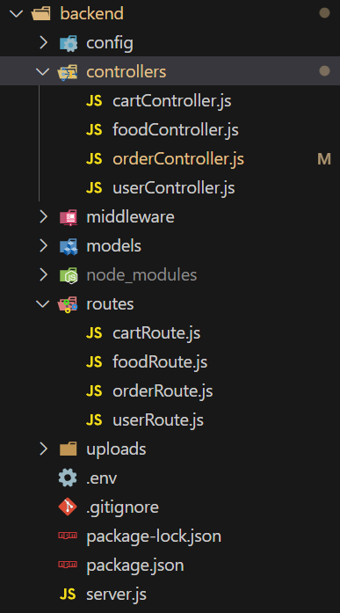

Key Components of the Router in the Backend
- Routing Framework/Library:
  - Most modern backend frameworks (like Express.js in Node.js) include a router feature that allows you to define routes easily.
- Defining Routes:
  - A route maps an HTTP method (e.g., GET, POST, PUT, DELETE) and a URL path to a handler function.

- Routing Middleware:
  - Middleware functions can process requests before they reach the route handler. Middleware can:
    - Authenticate requests.
    - Parse incoming data (e.g., JSON payloads).
    - Log requests.
- Dynamic and Parameterized Routes:
  - Routes can include dynamic segments to handle multiple similar endpoints.
javascript
- Modular Routing:
  - For better structure and maintainability, routes can be split into multiple files/modules.
javascript
Copy code
- Route Handlers:
  - A route handler is a function that executes the business logic when a specific route is accessed.

How Router Fits in the Backend Architecture
The router is part of the request-handling pipeline:

- Request: A client sends an HTTP request to the server (e.g., GET /api/users).
- Routing: The server matches the request's path and method to a route defined in the router.
- Middleware: Middleware functions are executed (e.g., authentication, data parsing).
- Handler: The route's handler function processes the request and sends a response.
- Response: The server sends back an HTTP response to the client.

ADMIN PANEL

AddFood.jsx
import axios from 'axios';
import React, { useState } from 'react';
import { toast } from 'react-toastify';
import { assets } from '../../assets/assets';
import './Add.css';

const Add = () => {

// const url="http://localhost:4000"
const url = "https://food-delivery-backend-au4q.onrender.com"
const [data, setData] = useState({
name: "",
description: "",
price: "",
category: "Cake"
});

const [image, setImage] = useState(false);

const onSubmitHandler = async (event) => {
event.preventDefault();
const formData = new FormData();
formData.append("name", data.name);
formData.append("description", data.description);
formData.append("price", Number(data.price));
formData.append("category", data.category);
formData.append("image", image);
const response = await axios.post(`${url}/api/food/add`, formData);
if (response.data.success) {
toast.success(response.data.message)
setData({
name: "",
description: "",
price: "",
category: "Cake"
})
setImage(false);
}
else{
toast.error(response.data.message)
}
}

const onChangeHandler = (event) => {
const name = event.target.name;
const value = event.target.value;
setData(data => ({ ...data, [name]: value }))
}

return (
<div className='add'>
<form className='flex-col' onSubmit={onSubmitHandler}>
<div className='add-img-upload flex-col'>
<p>Upload image</p>
<label htmlFor="image">
<img src={!image ? assets.upload_area : URL.createObjectURL(image)} alt="" />
</label>
<input onChange={(e) => { setImage(e.target.files[0]) }} type="file" id="image" hidden required />
</div>
<div className='add-product-name flex-col'>
<p>Product name</p>
<input name='name' onChange={onChangeHandler} value={data.name} type="text" placeholder='Type here' required />
</div>
<div className='add-product-description flex-col'>
<p>Product description</p>
<textarea name='description' onChange={onChangeHandler} value={data.description} type="text" rows={6} placeholder='Write content here' required />
</div>
<div className='add-category-price'>
<div className='add-category flex-col'>
<p>Product category</p>
<select name='category' onChange={onChangeHandler} >
<option value="Cake">Cake</option>
<option value="Fish">Fish</option>
<option value="Chicken">Chicken</option>
<option value="Mutton">Mutton</option>
<option value="Pure Veg">Pure Veg</option>
<option value="Rolls">Rolls</option>
</select>
</div>
<div className='add-price flex-col'>
<p>Product Price</p>
<input type="Number" name='price' onChange={onChangeHandler} value={data.price} placeholder='$25' />
</div>
</div>
<button type='submit' className='add-btn' >ADD</button>
</form>
</div>
)
}

export default Add

Order.jsx

import React, { useEffect, useState } from 'react'
import './Orders.css'
import { toast } from 'react-toastify';
import axios from 'axios';
import { assets, url } from '../../assets/assets';

const Order = () => {

const [orders, setOrders] = useState([]);

const fetchAllOrders = async () => {
const response = await axios.get(`${url}/api/order/list`)
if (response.data.success) {
setOrders(response.data.data.reverse());
console.log(response.data.data);
}
else {
toast.error("Error")
}
}

const statusHandler = async (event,orderId) => {
console.log(event,orderId);
const response = await axios.post(`${url}/api/order/status`,{
orderId,
status:event.target.value
})
if(response.data.success)
{
await fetchAllOrders();
}
}

useEffect(() => {
fetchAllOrders();
}, [])

return (
<div className='order add'>
<h3>Order Page</h3>
<div className="order-list">
{orders.map((order, index) => (
<div key={index} className='order-item'>
<img src={assets.parcel_icon} alt="" />
<div>
<p className='order-item-food'>
{order.items.map((item, index) => {
if (index === order.items.length - 1) {
return item.name + " x " + item.quantity
}
else {
return item.name + " x " + item.quantity + ", "
}
})}
</p>
<p className='order-item-name'>{order.address.firstName+" "+order.address.lastName}</p>
<div className='order-item-address'>
<p>{order.address.street+","}</p>
<p>{order.address.city+", "+order.address.state+", "+order.address.country+", "+order.address.zipcode}</p>
</div>
<p className='order-item-phone'>{order.address.phone}</p>
</div>
<p>Items : {order.items.length}</p>
<p>${order.amount}</p>
<select onChange={(e)=>statusHandler(e,order._id)} value={order.status} name="" id="">
<option value="Food Processing">Food Processing</option>
<option value="Out for delivery">Out for delivery</option>
<option value="Delivered">Delivered</option>
</select>
</div>
))}
</div>
</div>
)
}

export default Order

List.jsx

import axios from 'axios';
import React, { useEffect, useState } from 'react';
import { toast } from 'react-toastify';
import { url } from '../../assets/assets';
import './List.css';

const List = () => {

const [list,setList] = useState([]);

const fetchList = async () => {
const response = await axios.get(`${url}/api/food/list`)
if(response.data.success)
{
setList(response.data.data);
}
else{
toast.error("Error")
}
}

const removeFood = async (foodId) => {
const response = await axios.post(`${url}/api/food/remove`,{
id:foodId
})
await fetchList();
if (response.data.success) {
toast.success(response.data.message);
}
else {
toast.error("Error")
}
}

useEffect(()=>{
fetchList();
},[])

return (
<div className='list add flex-col'>
<p>All Foods List</p>
<div className='list-table'>
<div className="list-table-format title">
<b>Image</b>
<b>Name</b>
<b>Category</b>
<b>Price</b>
<b>Action</b>
</div>
{list.map((item,index)=>{
return (
<div key={index} className='list-table-format'>
<img src={`${url}/images/`+item.image} alt="" />
<p>{item.name}</p>
<p>{item.category}</p>
<p>${item.price}</p>
<p className='cursor' onClick={()=>removeFood(item._id)}>x</p>
</div>
)
})}
</div>
</div>
)
}

export default List

Admin folder image
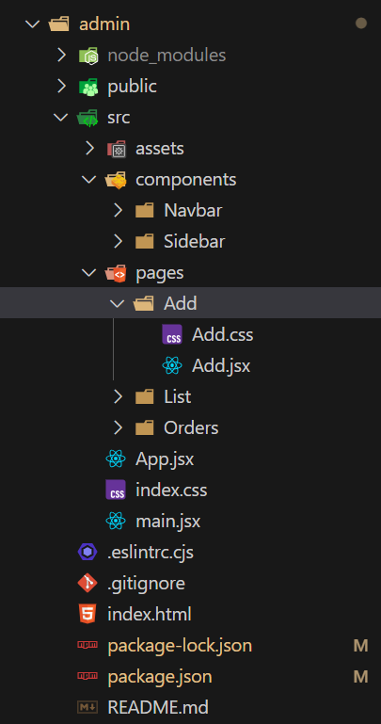

1. Install Postman

Download Postman:

Go to the Postman website and download the application for your operating system.

Install and Open Postman:

Follow the installation steps and launch the app.

2. Understand the Basics

Request Types: Common request methods include:

GET: Retrieve data from the server.

POST: Send data to the server.

PUT: Update existing data on the server.

DELETE: Remove data from the server.

Headers: Used to send additional information like authentication tokens or content type.

Body: Contains the data to send (used in POST or PUT requests).

Environment Variables: Store reusable variables like API URLs or tokens.

3. Create a Request

Launch Postman and click "New" > "Request".

Name the Request (e.g., "User Login") and add it to a collection or folder for organization.

4. Send a GET Request

Enter the Endpoint:

Example: https://api.example.com/users

Select the HTTP Method:

Choose GET from the dropdown next to the URL field.

Click "Send":

Postman will send the request and display the server's response in the lower pane.

Inspect the Response:

Check the status code, response time, and body.

5. Send a POST Request

Enter the Endpoint:

Example: https://api.example.com/users/login

Select POST Method:

Choose POST from the dropdown.

Add Headers (if required):

Example:

Content-Type: application/json

Go to the Headers tab and add key-value pairs.

Add Request Body:

Go to the Body tab and select raw.

Choose JSON format and enter the request payload:

json

{

"email": "test@example.com",

"password": "123456"

}

Click "Send":

Postman sends the data to the server, and the response appears in the lower pane.

6. Send a PUT Request

Enter the Endpoint:

Example: https://api.example.com/users/123

Select PUT Method.

Add Headers:

Example:

Content-Type: application/json

Add Request Body:

Go to the Body tab, select raw, and enter the updated data:

json

{

"name": "John Doe",

"email": "john.doe@example.com"

}

Click "Send":

View the updated response.

7. Send a DELETE Request

Enter the Endpoint:

Example: https://api.example.com/users/123

Select DELETE Method.

Click "Send":

Confirm deletion by inspecting the response.

8. Authentication in Postman

Go to the "Authorization" Tab:

Select the appropriate type (e.g., Bearer Token, Basic Auth).

Enter Credentials or Token:

Example: For Bearer Token, add:

makefile

CopyEdit

Token: eyJhbGciOiJIUzI1NiIsInR5cCI6IkpXVCJ9...

9. Save Requests in Collections

Organize related requests into Collections for easier management.

Save requests by clicking Save after sending them.

10. Use Environment Variables

Define Variables:

Example: Create a variable for BASE_URL as https://api.example.com.

Use Variables in Requests:

Replace the endpoint with {{BASE_URL}}/users.

Set Environments:

Switch between different environments like Development or Production.

11. Testing and Validation

Write Tests:

Add JavaScript-based tests under the Tests tab:

javascript

CopyEdit

pm.test("Status code is 200", function () {

pm.response.to.have.status(200);

});

Automate Tests:

Run multiple requests from a collection and validate responses.

12. Debugging

Check for errors in the response.

Use the Console (View > Show Postman Console) to inspect log

Conclusion:
It provides a simple way for customers to order food from a restaurant using their device, allowing them to enjoy their food within 45 minutes. It stores customer and food item details and generates bills to reduce time wasting and avoid misunderstandings compared to traditional in-person ordering. The system also allows users to easily modify their profile information like delivery addresses. Overall, the project aims to provide easy data flow, customer satisfaction, and less work through the developed online platform.

Finally, the creation of a food delivery application utilising the MERN stack resulted in a functioning and efficient system for ordering and delivering meals. The software allows users to explore menus and place orders thoroughly. while the restaurant can handle orders and change menu items in real-time.

Planning, design, execution, and testing were all part of the development process. The needs were identified and analysed during the planning stage, and a thorough project plan was prepared. Wireframes, mockups, and a database structure were all created throughout the design stage. The MERN stack was used for implementation, which provided a robust and versatile set of tools for creating both the application's front-end and back-end. A set of unit, integration, and acceptance tests was performed throughout the testing stage to confirm that the system fulfilled all criteria and was free of faults and mistakes.

The adoption of MongoDB as the application's database was especially advantageous since it allowed f or quick data storage and retrieval and provided a scalable solution that could manage massive volumes of data. Furthermore, using ReactJS as the frontend framework enabled a dynamic and interactive user experience with rapid rendering and enhanced speed.

Various testing methodologies, including unit, integration, and acceptability testing, were used to test the application. These tests were performed to confirm that the system satisfied all functional and non-functional criteria and was bug and error-free. Several difficulties were discovered throughout the testing phase, which were addressed and resolved in future rounds of the development process. Overall, the testing method was critical in guaranteeing the system's quality and dependability.

16.Reference:

- Admin and V. all posts by Admin, “How to Send Data from React to Node js Express + MySQL - Tuts Make,” Tuts Make, Oct. 30, 2022. [Online]. Available:
- https://www.tutsmake.com/how-to-send-data-from-react-to-node-js-express-mysql/
- “What is the meaning of ‘bodyParser.urlencoded({ extended: true }))’ and ‘bodyParser.json()’ in Express.js?,” Stack Overflow, Apr. 07, 2019. [Online]. Available: https://stackoverflow.com/questions/55558402/what-is-the-meaning-of-bodyparser-urlencode d-extended-true-and-bodypar
- A. Sen, “Node React Tutorial - How to connect React with backend Node.js?,” codedamn news, Sep. 14, 2022. [Online]. Available:
- https://codedamn.com/news/reactjs/how-to-connect-react-with-node-js
- “What does `app.use(bodyParser.json())` do?,” Stack Overflow, Oct. 05, 2016. [Online].
- Available: https://stackoverflow.com/questions/39870867/what-does-app-usebodyparser-json-do

17. Challenges

Technical Challenges
  - Integration with multiple restaurants: Integrating with various restaurants, each with their own menu, pricing, and availability.
  - Real-time tracking and updates: Providing real-time tracking and updates on order status, delivery location, and estimated delivery time.
  - Payment gateway integration: Integrating with payment gateways to facilitate secure and efficient transactions.
  - Scalability and performance: Ensuring the system can handle a large volume of orders and traffic without compromising performance.
  - Security and data protection: Protecting sensitive customer data, such as payment information and personal details.

Logistics and Operational Challenges
  - Restaurant partnership and management: Building and maintaining relationships with restaurants, managing menus, and ensuring consistent quality.
  - Delivery logistics and fleet management: Managing a fleet of delivery drivers, optimizing routes, and ensuring timely deliveries.
  - Order management and fulfillment: Managing orders, handling cancellations, and ensuring accurate fulfillment.
  - Customer support and service: Providing excellent customer support, handling complaints, and resolving issues.
  - Compliance with regulations and laws: Ensuring compliance with food safety regulations, labor laws, and other relevant laws.

Business Challenges
- Competing with established players: Competing with existing food delivery services, such as GrubHub, UberEats, and DoorDash.
- Acquiring and retaining customers: Attracting and retaining customers in a crowded market.
- Managing commission fees and revenue: Balancing commission fees with revenue goals and ensuring profitability.
- Maintaining restaurant relationships: Building and maintaining strong relationships with restaurants to ensure a consistent and high-quality offering.
- Scaling the business: Scaling the business while maintaining quality, efficiency, and profitability.

18. Limitations

Despite offering a functional and user-friendly platform for online food ordering, the Khana Khazana application has some limitations which can be addressed in future updates:

🔹 1. No Live Map-Based Tracking
The application currently allows order status tracking through status updates, but it does not include real-time GPS-based tracking of the delivery person on a map.

🔹 2. Single Admin Panel
There is no separate dashboard for different admin roles like restaurant owner, manager, or super admin. All admin operations are handled from a common interface.

🔹 3. No SMS or Email Notifications
The system does not send order confirmation or status updates via SMS or email, which may limit communication with the customer.

🔹 4. No Ratings or Reviews
Customers cannot leave ratings or feedback for food items or delivery services, which is important for quality assurance and user engagement.

🔹 5. Limited Payment Options
Only Razorpay is integrated as a payment method. Support for other gateways like PayPal, UPI, or Cash on Delivery is not available.

🔹 6. No Coupon or Offer System
There is no feature to apply discount codes, offers, or loyalty points, which are commonly expected in food delivery apps.

🔹 7. Not Yet Optimized for Scale
While the app runs smoothly in small-scale testing, it has not yet been tested or optimized for high-traffic production environments or cloud scaling.

19. Future Scope

User-Facing Features
    - Personalized Recommendations: Implement a recommendation engine that suggests restaurants and dishes based on users' order history and preferences.
    - Real-time Order Tracking: Provide real-time updates on order status, including preparation, pickup, and delivery.
    - In-App Chat Support: Offer in-app chat support for customers to resolve issues or ask questions.
    - Restaurant Reviews and Ratings: Allow users to leave reviews and ratings for restaurants and dishes.
    - Loyalty Program: Implement a loyalty program that rewards customers for repeat orders or referrals.
    - Social Sharing: Allow users to share their orders on social media platforms.
    - Order Scheduling: Enable users to schedule orders in advance.
    - Dietary Restrictions and Preferences: Allow users to filter restaurants and dishes based on dietary restrictions and preferences.

Restaurant-Facing Features
- Restaurant Dashboard: Provide a dashboard for restaurants to manage their menu, orders, and customer interactions.
- Order Management: Enable restaurants to manage orders, including accepting, rejecting, or modifying orders.
- Menu Management: Allow restaurants to update their menu, including adding, removing, or modifying dishes.
- Customer Insights: Provide restaurants with insights into customer ordering habits and preferences.
- Restaurant Analytics: Offer analytics and reporting tools for restaurants to track sales, orders, and customer engagement.

Operational Features
- Automated Dispatch System: Implement an automated dispatch system to optimize delivery routes and reduce delivery times.
- Real-time Traffic Updates: Integrate real-time traffic updates to optimize delivery routes and reduce delivery times.
- Delivery Driver Management: Provide tools for managing delivery drivers, including tracking, routing, and communication.
- Order Fulfillment Management: Implement a system for managing order fulfillment, including tracking, inventory management, and logistics.
- Customer Service Tools: Provide customer service representatives with tools to manage customer inquiries, issues, and feedback.

Payment and Security Features
    - Secure Payment Processing: Implement secure payment processing to protect customer payment information.
    - Multiple Payment Options: Offer multiple payment options, including credit cards, digital wallets, and online banking.
    - Transaction History: Provide customers with a transaction history, including order details and payment information.
    - Refund and Cancellation Policy: Implement a refund and cancellation policy to protect customers in case of issues with orders.

Other Features
- Integrations with Third-Party Services: Integrate with third-party services, such as Google Maps, to enhance the user experience.
- Machine Learning and AI: Implement machine learning and AI to optimize operations, improve customer experience, and enhance decision-making.
- Data Analytics and Reporting: Provide data analytics and reporting tools to help restaurants and administrators make data-driven decisions.

20. OUTPUT

Screenshots

Landing Page
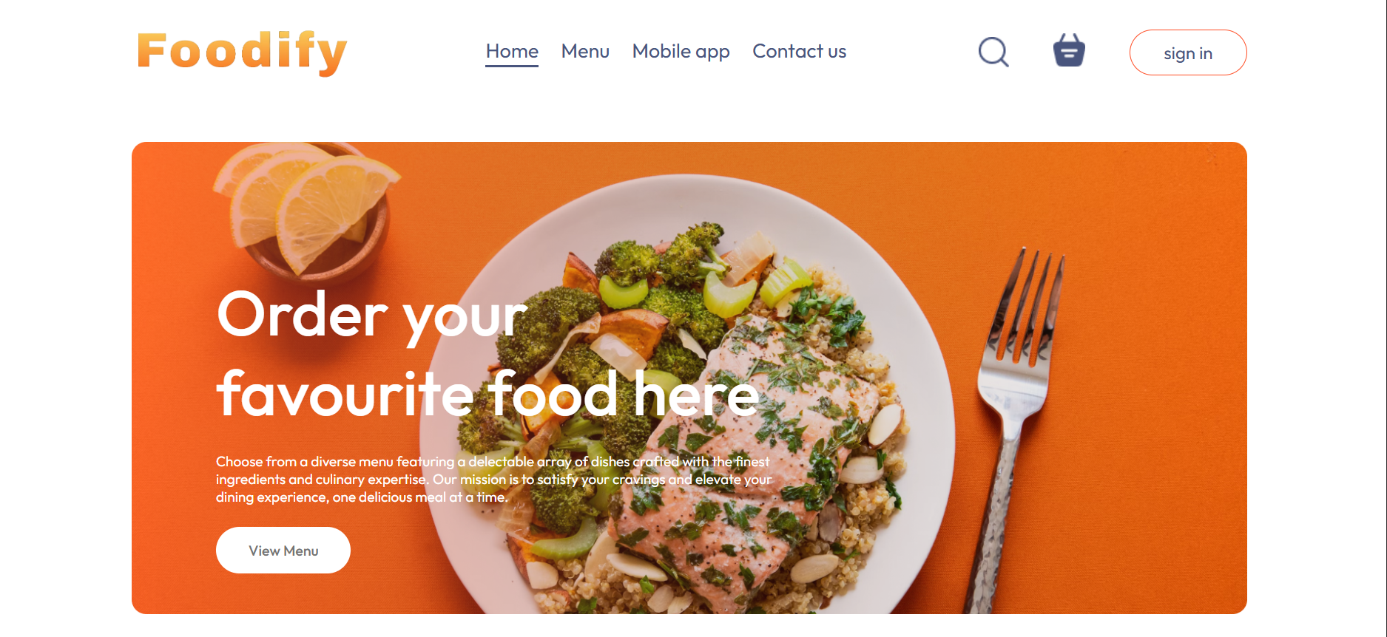


Responsive View

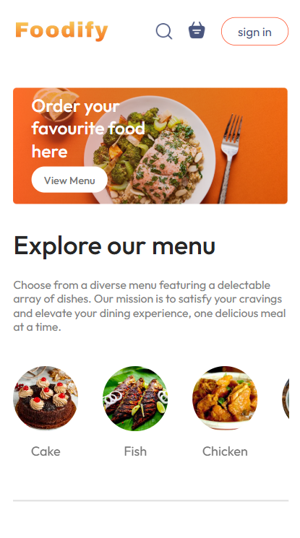

Signup Page


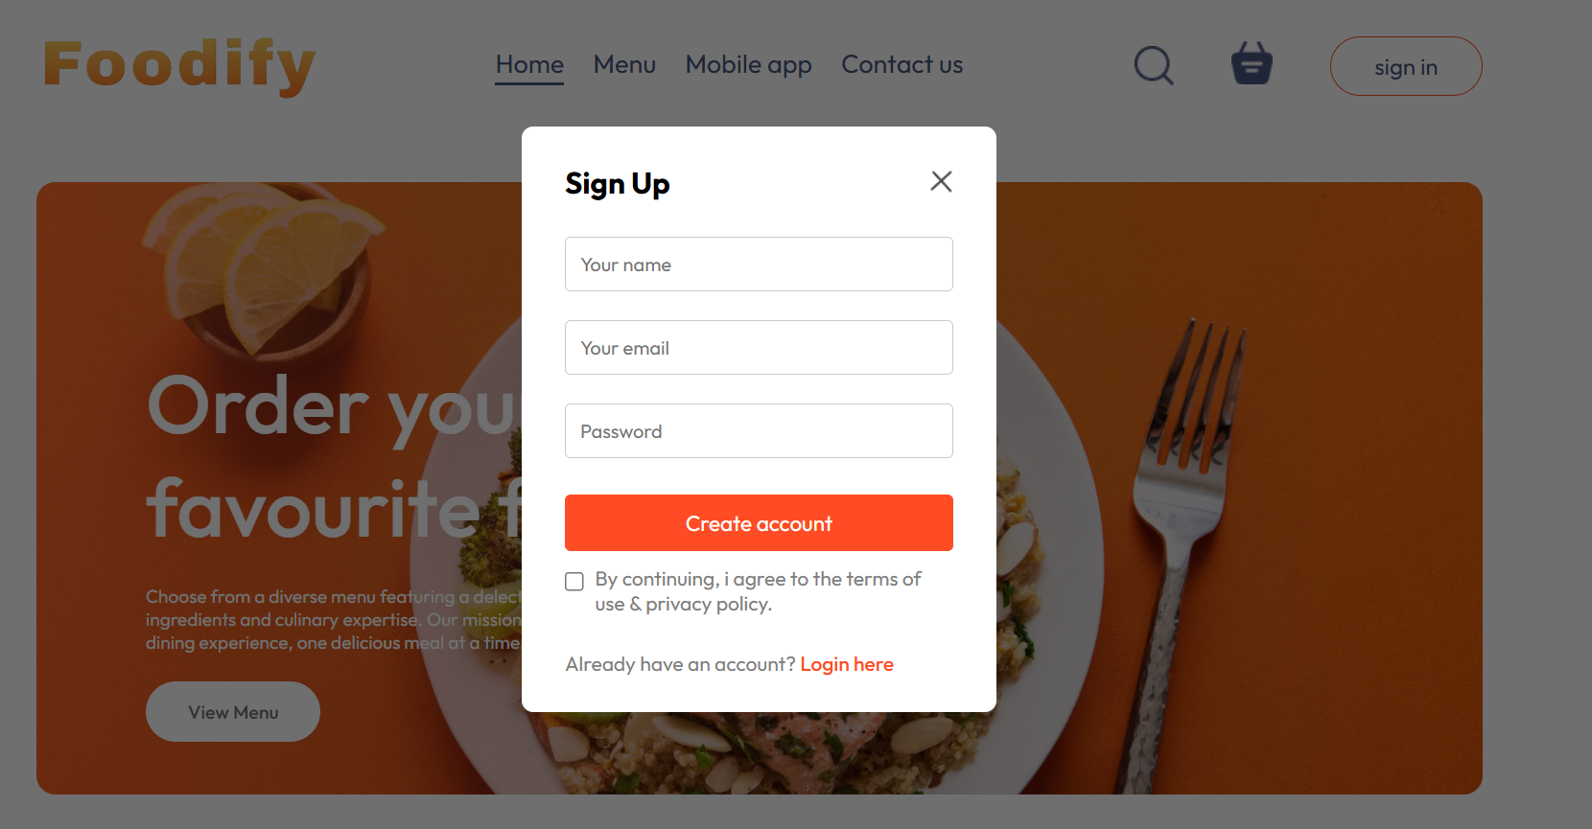

Login Page

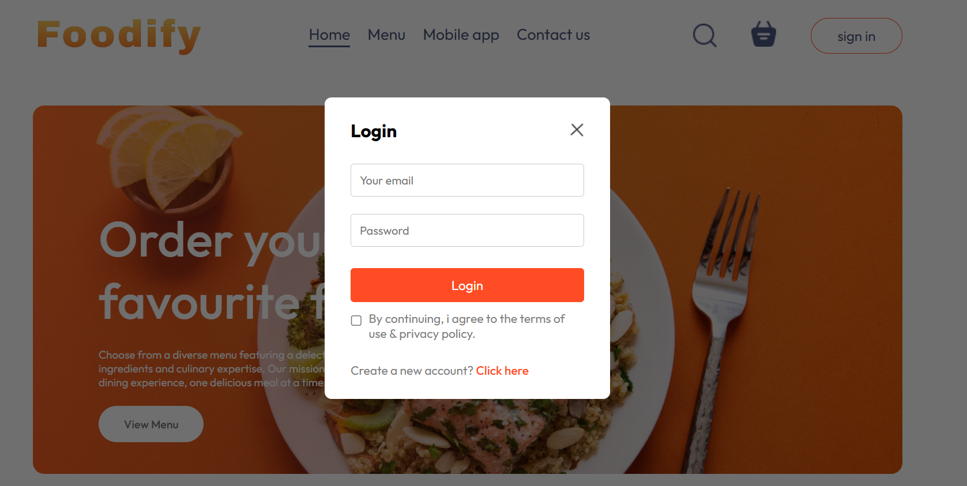

Menu List

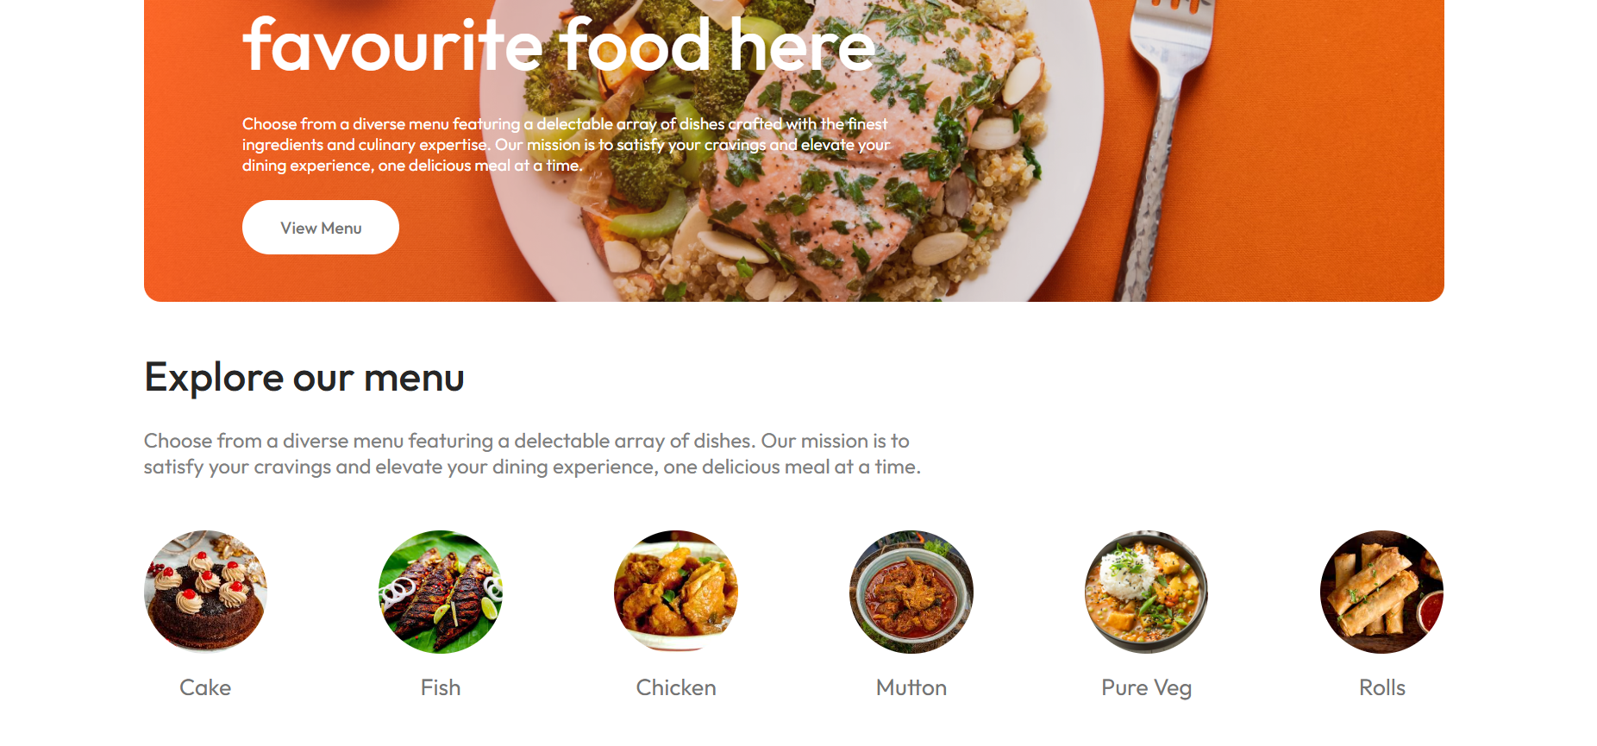

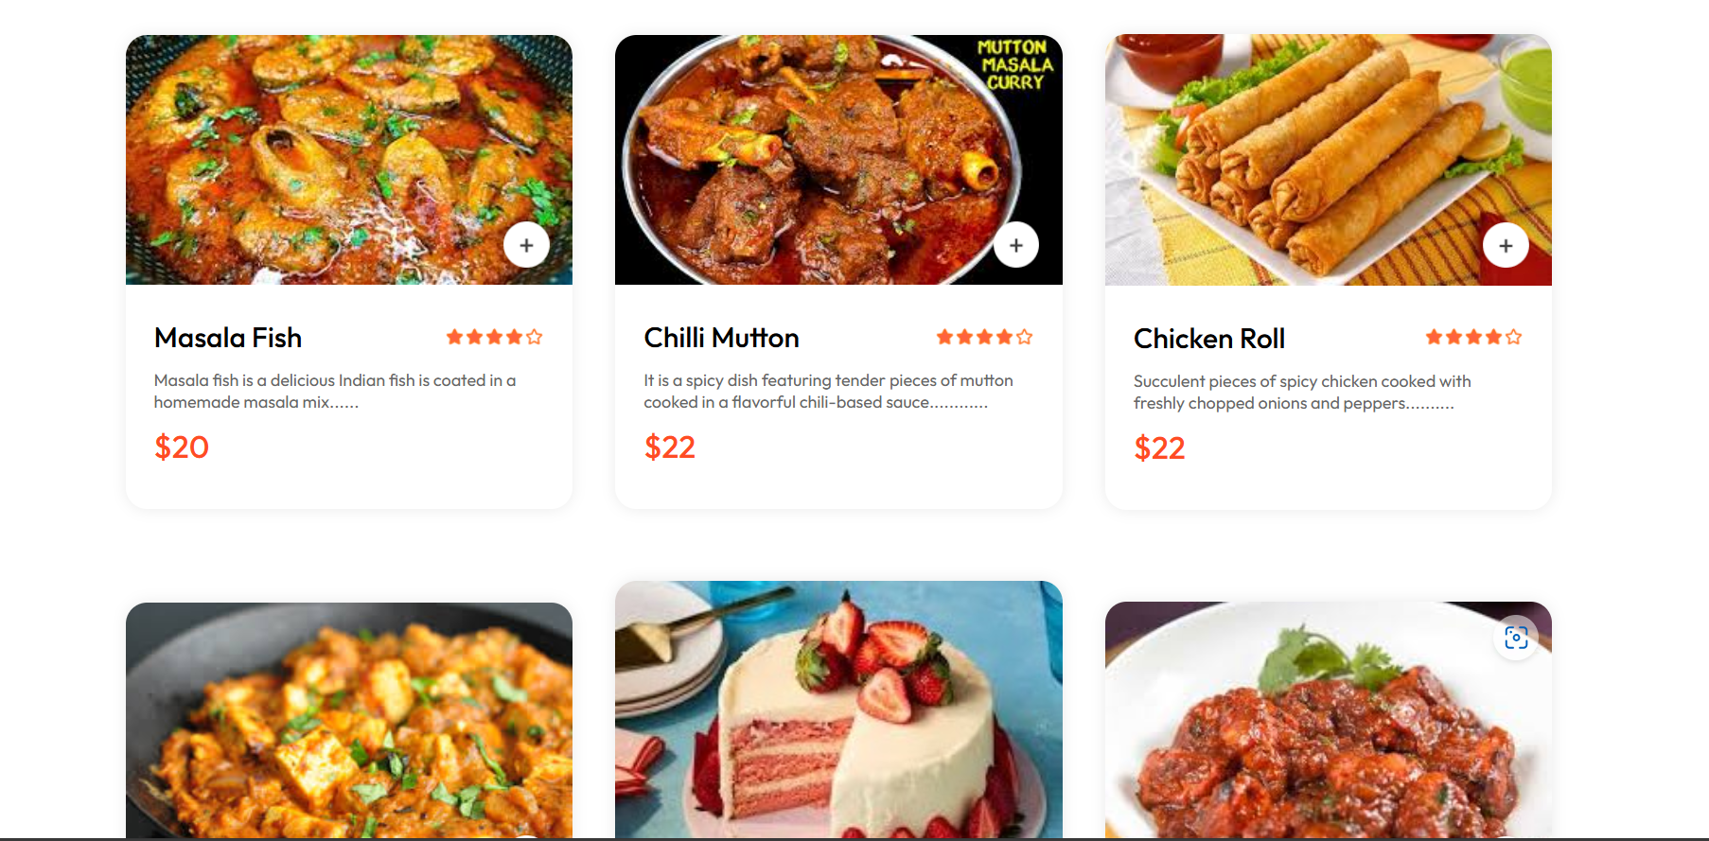

Footer Image

Khana Khazana



Order Image

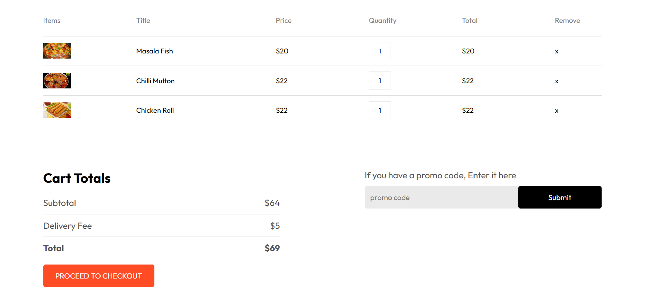

Payment Interface


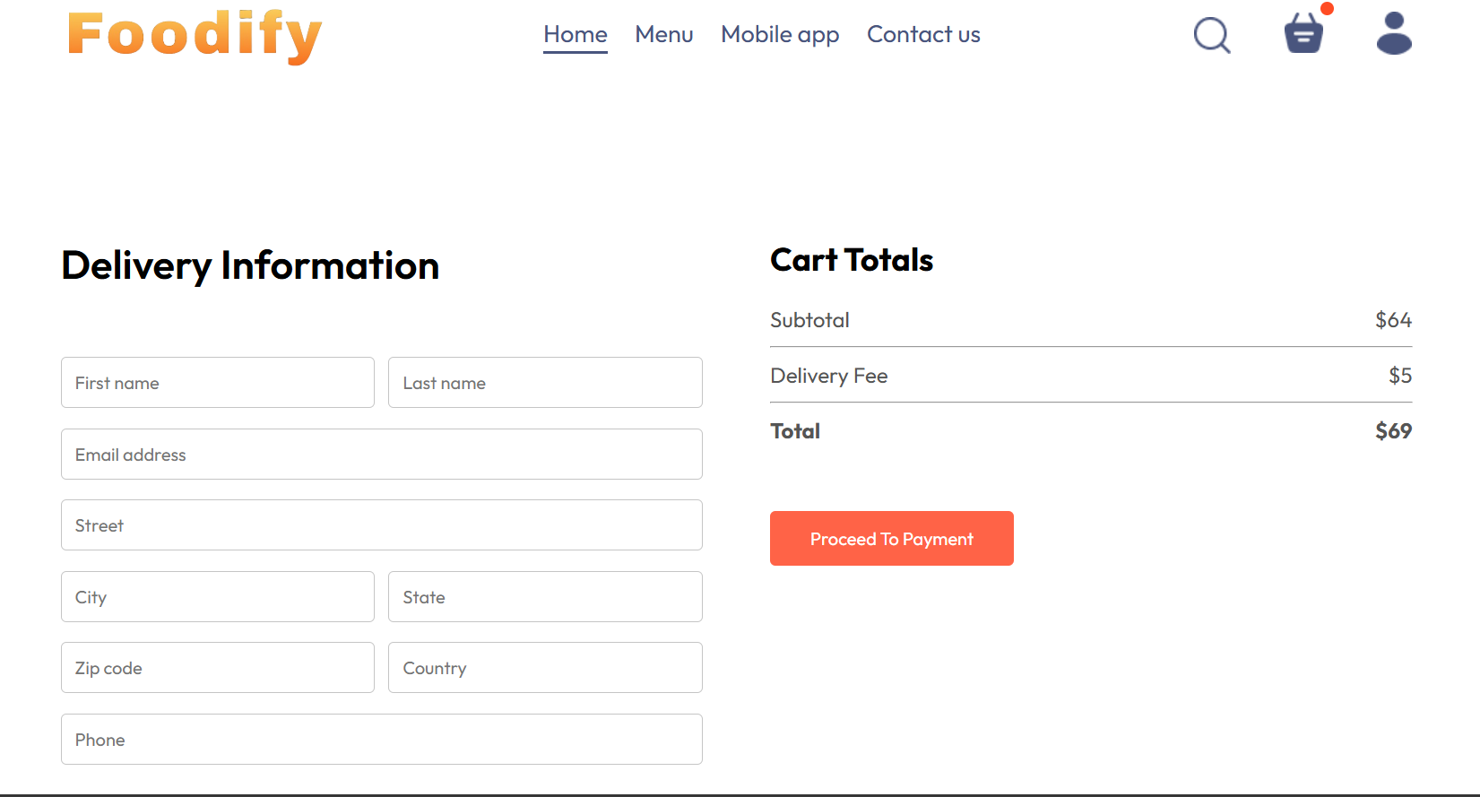

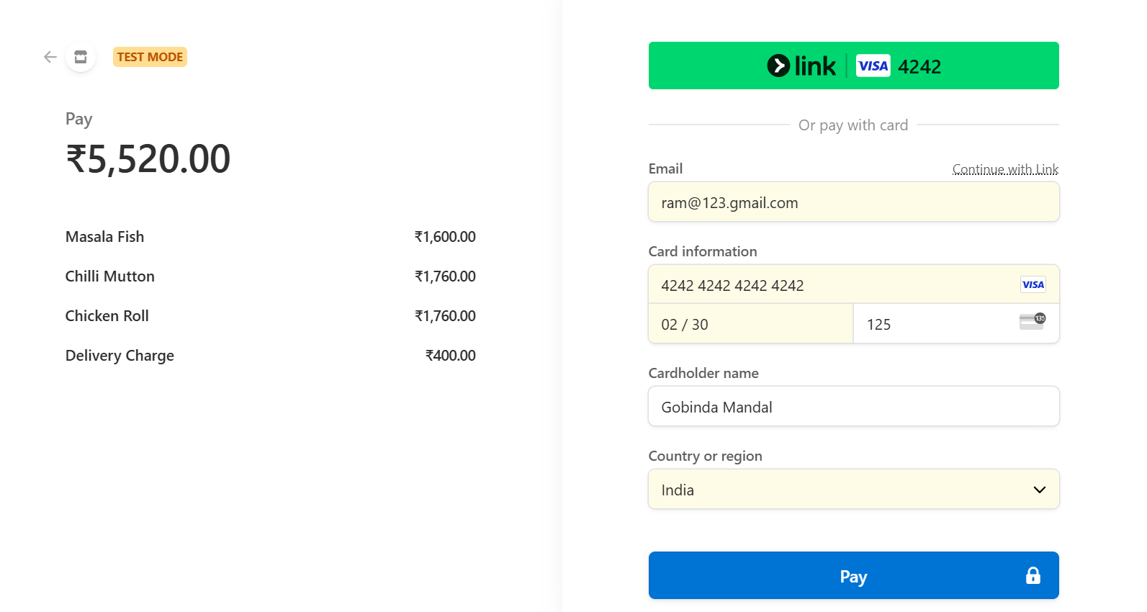

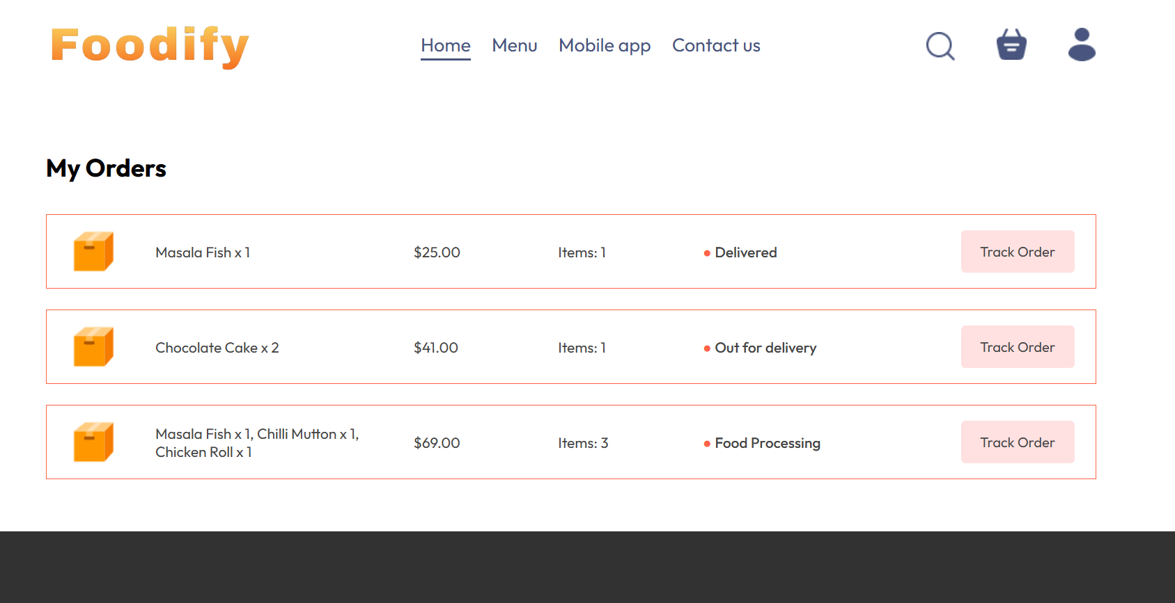
My Orders


Admin Panel
Add Food

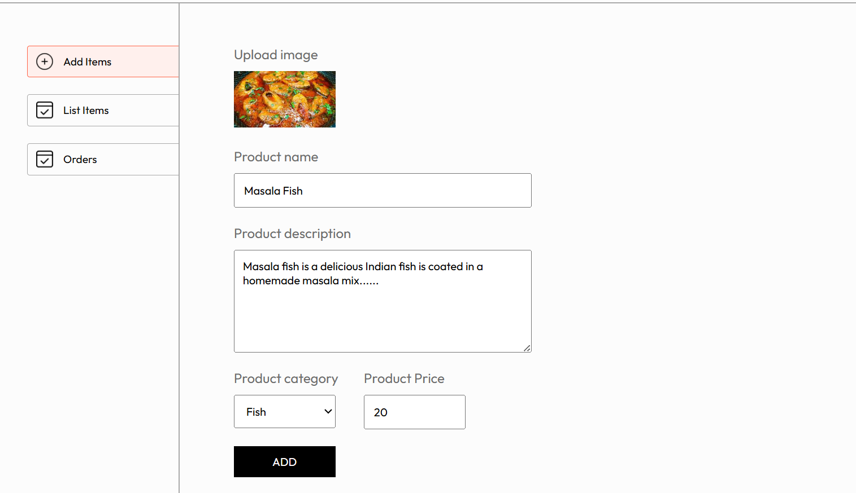

List of Foods
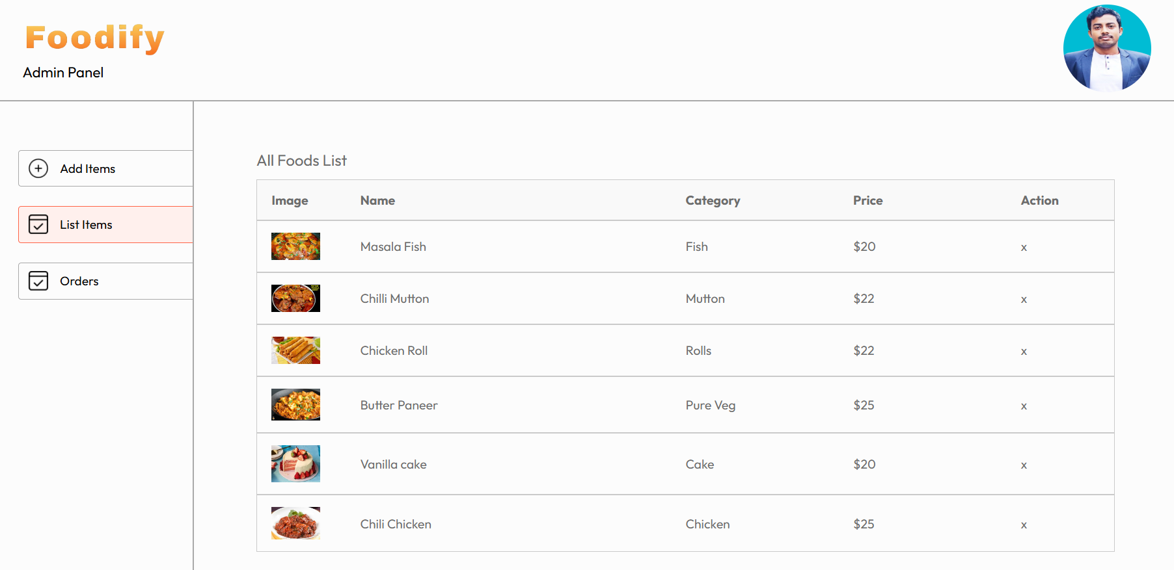


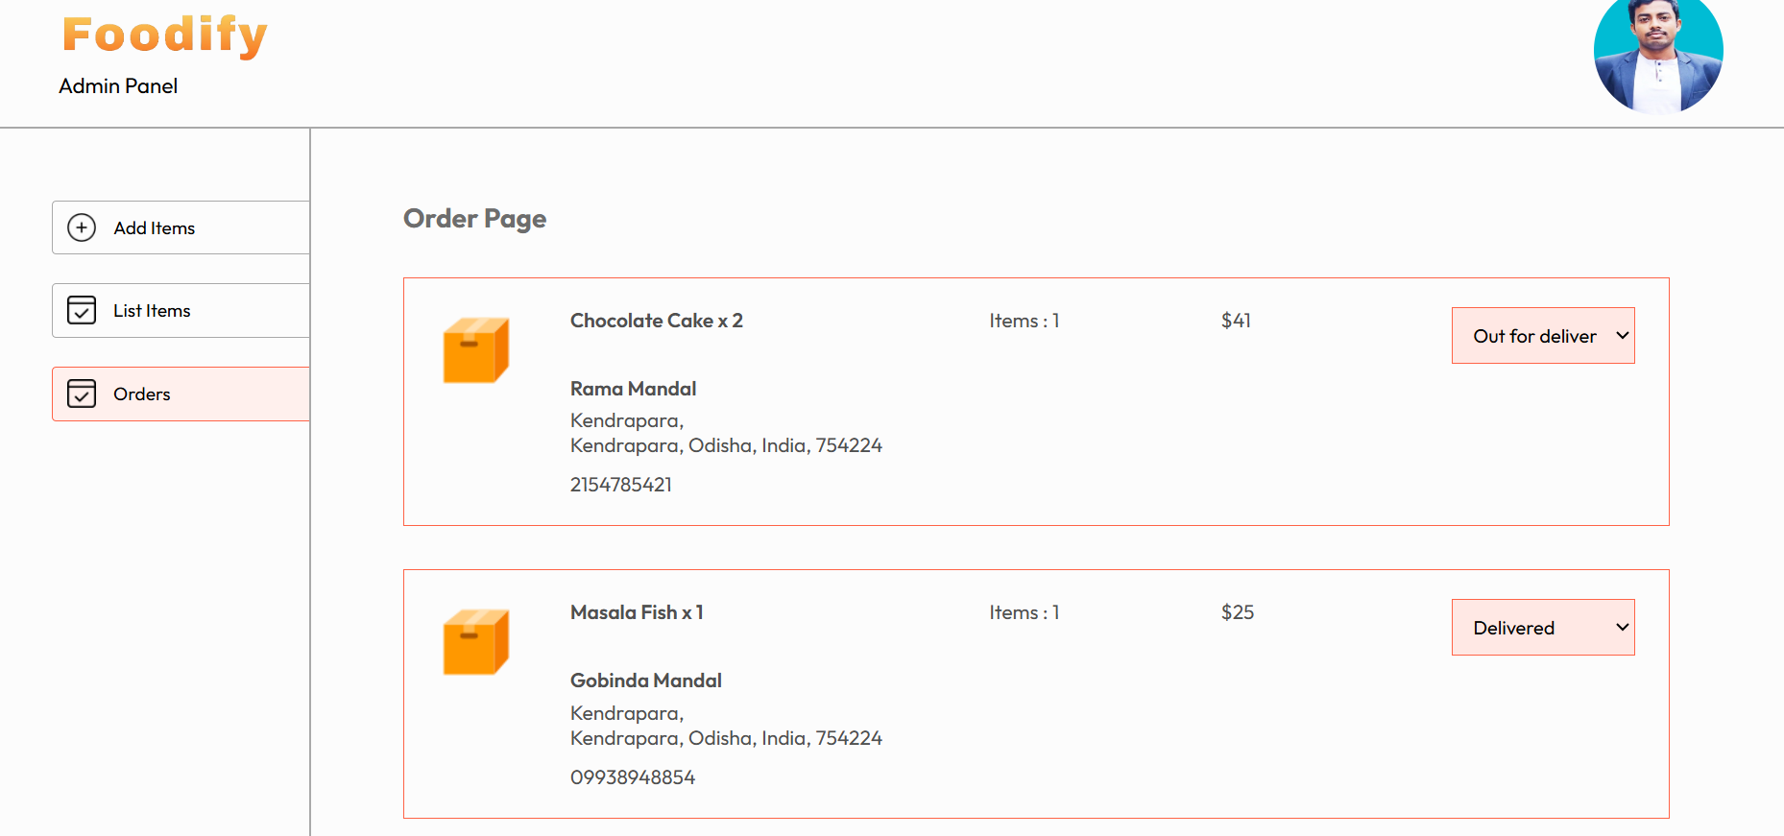
Orders

